MEMO

**FROM:** Edward Ma, W0057568, 701

**TO:** Bill Cunningham

**DATE:** 11-7-2016

**SUBJECT**: DBAS 1001 Assignment #5

* **Existing System Details:**
  + I need to find a job that will not kill me
* **Statement of Requirements**:
  + to analyze two job ads to determine what job roles they require
  + **Job 1:**



* + **Job 2:**



* **Analysis:**
  + show the content of the job ads and your conclusions regarding what job roles they include
  + ***Job 1:***

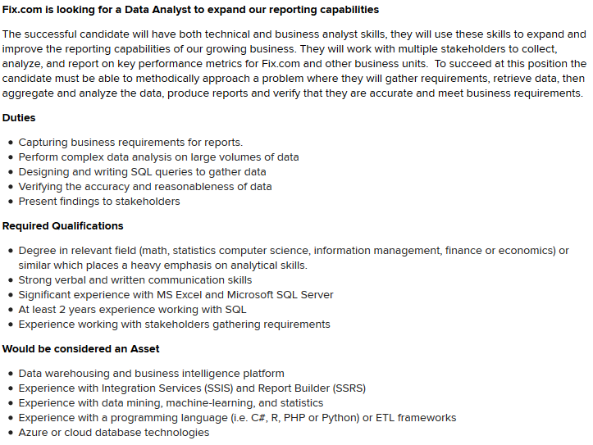

* + ***Job 2:***

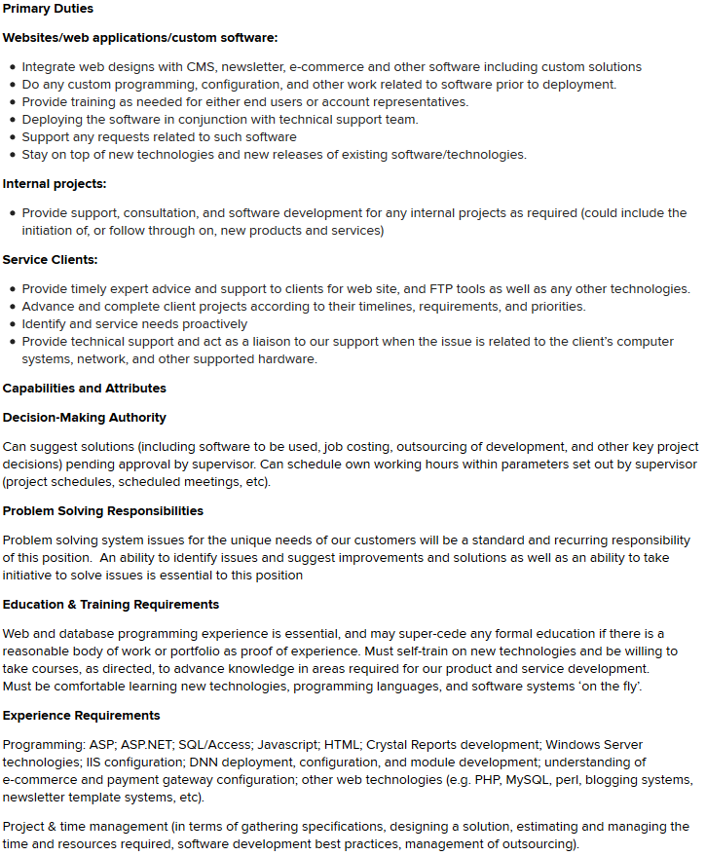

* **Recommendation:**Base on the job descriptions and what I personally enjoy doing. The Data Analyst position is the ideal, as I would not only get to analysis the flow of data and be able to produce result that would fit individual business needs for their day to day operations but always for future expansion base on the trend of the data.